Capstone Project Weekly Progress Report
Semester | Fall-2024 Semester 3rd
Course Code | AML-3406
Section | Section 1
Project Title | Car Damage Detection
Group Name | Group B
Student names/Student IDs | Sakshi (C0908000)  Bansil Patel (C0912873)  Harsh Mohile (C0912872) – TL  Meet Patel (C0910378)  Rachit Bhatt (C0902810)
Reporting Week | Week 3
Faculty Supervisor | William Pourmajidi

Grade the level of collaboration from different aspects between team members:
(use: good, medium, below expectation)
Sakshi | Bansil Patel | Harsh Mohile | Meet Patel | Rachit Bhatt
Good | Good | Good | Good | Good

Tasks outlined in the previous Weekly Progress Report for this reporting week at the individual level and group level
  - Individual tasks (each team member)
Sakshi: Defining phases of project and analyzing post requirements of project.
Bansil Patel: Practicals of learning – Computer Vision.
Harsh Mohile: Research on Deployment Platforms.
Meet Patel: Learning GitHub Management.
Rachit Bhatt: Creating demo for CI/CD Pipeline.
2.2 Your team’s tasks
- Initiate work on the project concepts.
- Understand the suitable deployment platforms.

Progress made in Reporting Week at an individual level and group level
  - Individual progress
Sakshi: Analyzed various phases of SDLC and Agile following Scrum with GitHub.
Bansil Patel: Motion Filtering, Edge Detection, OCR, Image Compression (PCA).
Harsh Mohile: Helped in implementation of CI/CD Pipeline Demonstration.
Meet Patel: Applied Git concepts to their personal demo environment.
Rachit Bhatt: Implemented a demonstration of CI/CD Pipeline.
  - Your team’s progress
- Implemented CI/CD Pipeline Demonstration.
- Researched on concepts of Computer Vision.
- Initial understanding of GitHub.
- Initialized GitHub as per Agile Methodology.

The areas/tasks you could not make progress and/or complete as scheduled or the difficulties encountered in this reporting week at individual level and group level.
  - Individual project blockers
Sakshi: N/A
Bansil Patel: Understanding the concept of edge detection was challenging.
Harsh Mohile & Rachit Bhatt: A lot of trails were taken to fix minor bugs in implementing CI/CD Pipeline.
Meet Patel: Using Git commands was challenging in front User-Friendly GitHub interface.
  - Your team’s project blockers
- Git on command-prompt.
- Time for testing CI/CD Pipeline.

Tasks to be completed in next week at individual level and group level
Learning VS Code will be a common task for the entire team in the next scrum.
  - Individual tasks
Sakshi: Learning VS Code + Learning GitHub.
Bansil Patel & Meet Patel: Learning VS Code + Exploring Dataset.
Harsh Mohile & Rachit Bhatt: Learning VS Code + Creating Branches for automation and deployment, and over Git Management.
  - Your team’s tasks
- Adapting VS-Code as IDE for development and version control.
- GitHub Management.
- Exploring Dataset.

Include the tasks from your sprint planning (Github/Zenhub) for the present period.
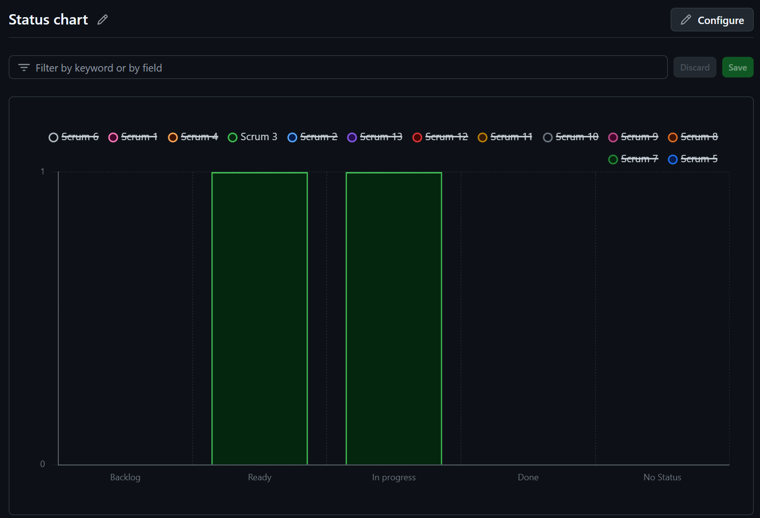
Figure 1: Status Chart of GitHub Issues in Milestone
Since all of the tasks have not been completed, some of the tasks would be available in the next scrum.

Include charts/graphs (e.g., burn down charts) from your project management tool (Github/Zenhub) that shows your progress for the period of this report.
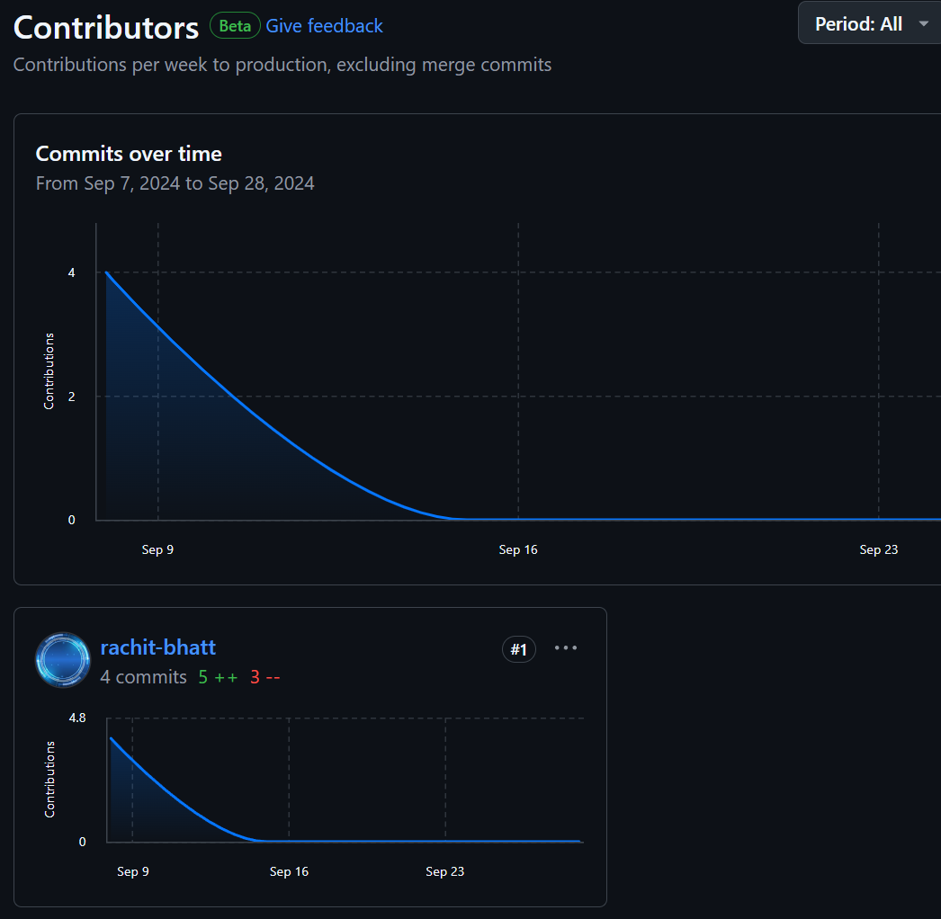
Figure 2: Highest Contributor of the Week

Include a note and address to your project Github with list of codes uploaded/updated on Github in this reporting week.
GitHub: https://www.github.com/rachit-bhatt/Capstone-Project
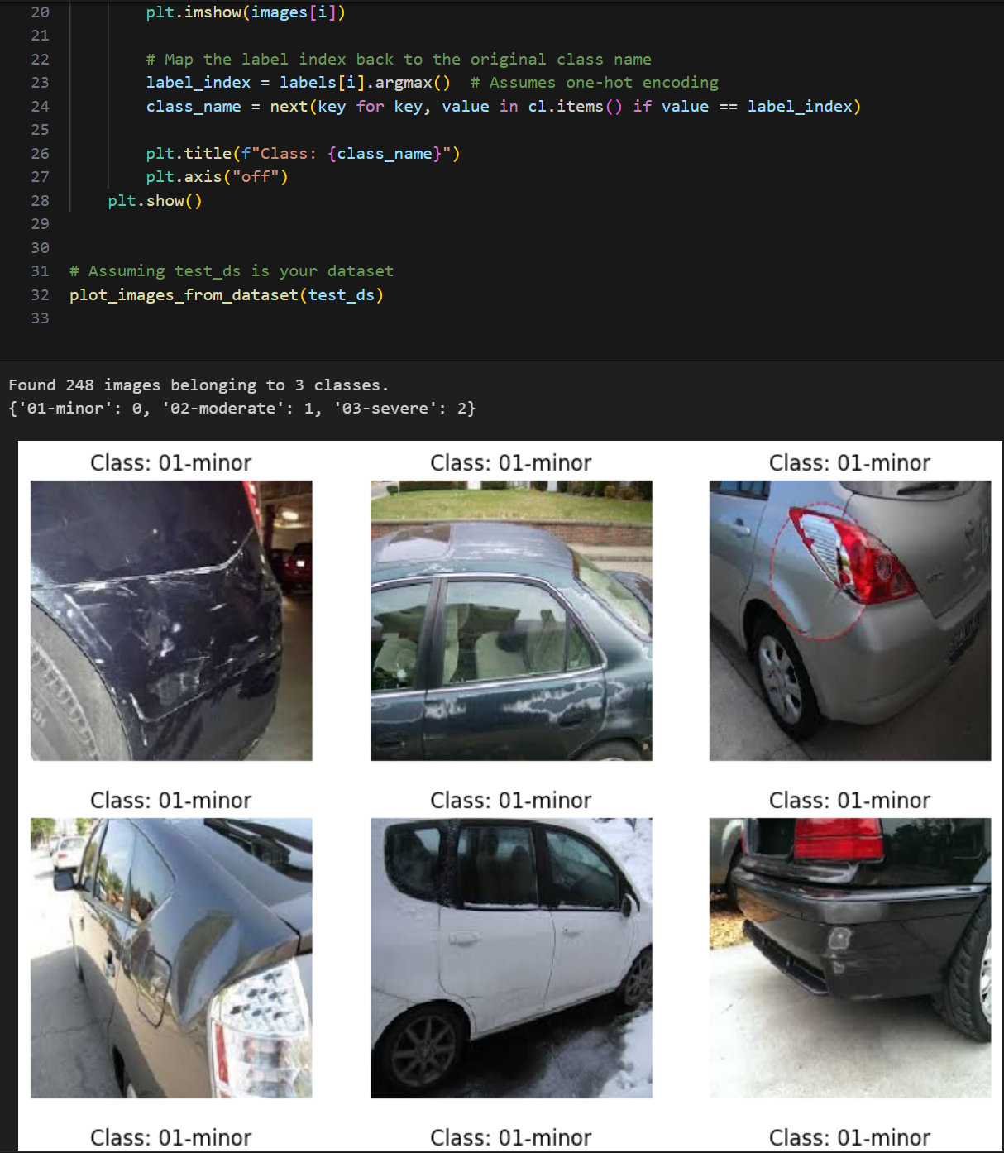
Figure 3: Categories of Images of a Damaged Car.

